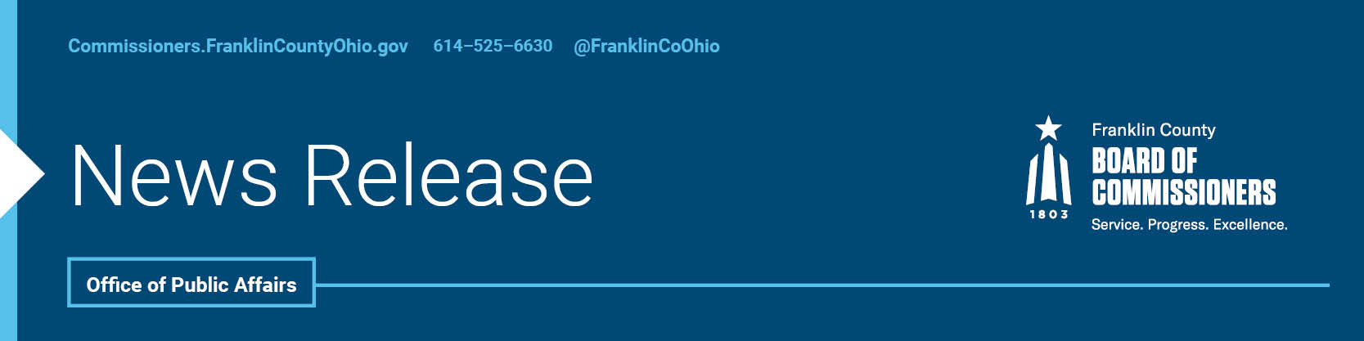

**FOR IMMEDIATE RELEASE**

**Thursday, September 7, 2023**

Contact: Tyler Lowry, Commissioners, 614/525-6630

Robin Ross, Commissioners, 614/525-2392

**FRANKLIN COUNTY CONTINUES TO LEAD NATIONALLY**

The Franklin County Board of Commissioners, county administration, and several of their top staff are again selected to serve in leadership positions this year with the National Association of Counties (NACo). The organization represents nearly 40,000 elected officials serving in the more-than 3,000 American counties, helping share best practices among communities from across the nation and representing the interests of counties in Washington D.C. As usual, Franklin County has more staff and commissioners among NACo leadership than any other county in Ohio.

Board President John O’Grady will be serving as vice-chair of the Large Urban County Caucus, which represents the 160 million residents who live in our nation’s metropolitan counties. He will also hold a seat on NACo’s Board of Directors, which is instrumental in advocating for county priorities and policies and optimizing county and taxpayer resources.

Commissioner Kevin L. Boyce will be serving this year as vice chair of the Telecommunications and Technology Steering Committee, which works on all matters pertaining to telecommunications and technology policy, including IT innovations, geospatial data collection and utilization, and cable technology and implementation. He is also part of the Large Urban County Caucus and the Immigration Reform Taskforce.

County Administrator Kenneth N. Wilson is beginning his two-year term as President of the National Association of County Administrators. Administrator Wilson has a strong background in overseeing the county’s core services and operations, running the daily operations, implementing the board’s policies, and preparing the annual budget. He is just as committed to his national role by encouraging professional development and providing information and resources to improve the effective management of county governments nationwide.

“NACo is an incredible asset for counties all over America, connecting leaders so that we can learn from each other, and representing the interests of county governments at the highest levels in Washington D.C. is critical” said Administrator Wilson. “Sharing our leadership skills assures us that Franklin County’s residents’ needs, and concerns are heard, and allows us to be a resource and asset to the organization as well as to our fellow county officials across the country.”

In addition, several other county staffers will be serving on NACo committees this year. Deputy County Administrator Joy Bivens will be on the Human Services and Education steering committee, Justice Policy and Programs Director, Ruchelle Pride will serve on the Justice and Public Safety steering committee, and the commissioners’ Chief Information Officer, Juan Torres, and Chief Information Officer of the Franklin County Data Center, Adam Frumkin, are vice chairs of the Information Technology Standing Committee.

To learn more about NACo and how it supports and represents the nation’s counties, visit [NACo.org](https://www.naco.org/resources/reports-and-publications?sort=desc).

--30--

For more information on the Franklin County Board of Commissioners, log on to: https://commissioners.franklincountyohio.gov/