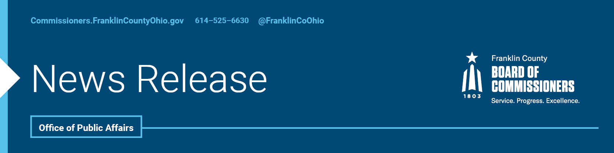

**FOR IMMEDIATE RELEASE**

**Tuesday, July 9th, 2024**

Contact: Isabella Minadeo, Commissioners, 614/525-3462

Robin Ross, Commissioners, 614/525-2392

**COMMISSIONERS APPROVE GRANTS EXCEEDING $3.7 MILLION TO FRANKLIN COUNTY NONPROFITS**

The Franklin County Commissioners announced this morning that they are awarding $3,740,145 in grants to community partner organizations that will promote equity for all Franklin County residents. The twenty-two grant recipients were selected for their initiatives aimed at reducing disparities and addressing the needs of historically underserved populations.

"Promoting economic opportunities and stability for our residents is essential to building a more equitable Franklin County," said Board of Commissioners President, Kevin L. Boyce. "By investing in initiatives that create well-paying jobs, support local businesses, and foster economic development, we are ensuring that all members of our community have the chance to thrive. Our commitment to economic equity is a cornerstone of our mission to enhance the quality of life for every resident."

This grant is available annually to 501(c)(3) nonprofit organizations in Franklin County. The grants process is highly competitive and represents our largest competitive grant each year. Each organization can apply for up to $500,000 in funding for their program, and if the program shows success over the course of the funding period, it may be eligible for continued funding for two additional one-year periods. The grants are administered by the commissioners’ Community Partnership agency, which has awarded similar grants since 2021, in alignment with the commissioners’ 2019 [Rise Together Blueprint for Addressing Poverty in Franklin County](https://risetogether.franklincountyohio.gov/).

“Administering these grants plays a crucial role in empowering our community by providing the necessary resources for local organizations to implement impactful programs.” said Commissioner John O’Grady “They enable us to address pressing issues, foster innovation, and create opportunities for growth and development that benefit all residents.”

Franklin County is dedicated to enhancing the lives of all its residents daily. By collaborating with non-profit organizations, local vendors, business owners, and national, state, and local governments, we strive to ensure that county agencies deliver services efficiently and effectively. Additionally, the commissioners work directly with community agencies to create well-paying jobs, promote economic development, embrace racial equity, improve access to affordable healthcare, stabilize families and children, and protect the environment. Community Partnerships supports these efforts through its grant program.

"Investing in our community is essential for building a strong, vibrant, and equitable society.” said Commissioner Erica Crawley “These grants support initiatives that drive positive change, enhance the quality of life for our residents, and ensure that essential services reach those who need them most."

The commissioners’ resolutions approving these grants and more information about them are available here and here, and information about the commissioners’ Community Partnerships Program and future funding opportunities can be found [here](https://budget.franklincountyohio.gov/Partnerships). A full list of recipients is provided below.

--30--

For more information on the Franklin County Board of Commissioners, log on to: <https://commissioners.franklincountyohio.gov/>

