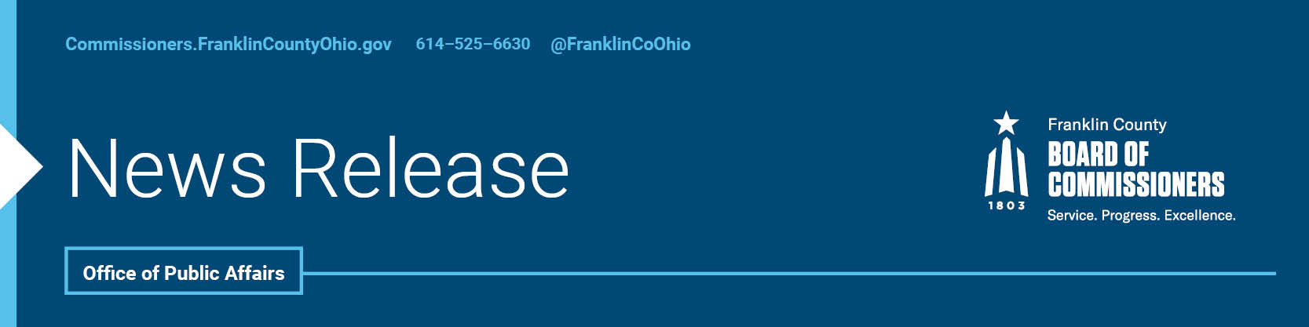

FOR IMMEDIATE RELEASETuesday, June 16, 2020

Contact: Jodi Andes, Commissioners, 614/525-6273
Tyler Lowry, Commissioners, 614/525-6630
Jaclyn Reynolds, COSI Director of Communications, 614/629-3114

PUBLIC-PRIVATE PARTNERSHIP TO BRING DISTANCE LEARNING AND SCIENCE ACTIVITIES TO CHILDREN COUNTYWIDE ALL SUMMER
The pandemic may be limiting where youth can go this summer, but a new public-private partnership between COSI and the Franklin County Commissioners will ensure that youth still have plenty to do.
The Franklin County Commissioners and the Center of Science and Industry (COSI) have teamed up to create free educational and entertaining activities rooted in Science, Technology, Engineering, and Math (STEM) that will be catered to students in kindergarteners through high school. These new activities and videos will be available on the COSI Connects webpage starting later this month and will be posted daily into the fall.
In addition to being online, the activities will also be available in hands-on kits that will be delivered to children in under-served areas where many homes do not have Internet access, predominately sites where Franklin County children already frequent for free meals during the summer.
“This pandemic is not going away, leaving many of our youth with few options this summer. There are not as many summer camps, open pools or activities, and given the advice to social distance, parents may prefer to keep their children close to home,” said John O’Grady, President of the Franklin County Board of Commissioners. “We want to provide an outlet that is a safe option for youth to occupy their time.”
COSI worked with the Children’s Hunger Alliance to determine where the hands-on activities will be available.
“This is a tremendous partnership and we are pleased to be able to offer education opportunities to children throughout Franklin County, including in underserved neighborhoods, that are not only fun but hands-on and engaging,” said Dr. Frederic Bertley, COSI President and CEO. “We are proud that COSI can help provide critically needed STEM educational content both through its COSI Connects platform and physical COSI kits to help close the education gap. This partnership will deliver distance learning when it is needed the most for parents and kids and we are thankful for the support and leadership of the Franklin County Commissioners as we work together to overcome this pandemic.”
In addition, COSI is developing an app so that a week’s worth of activities can be downloaded at free hotspots such as libraries and community centers, providing another option for families who don’t have the Internet in their home. The app is expected to be available by mid-summer.
This partnership was formerly approved by the commissioners this morning and provides COSI $250,000 to aid in it the program’s development. The STEM activities will vary day today, but are likely to include some of COSI’s more popular categories like superheroes, dinosaurs, space and at-home fun science. Furthermore, the activities are designed with Ohio’s required education curriculum in mind.
“There can be a learning gap in the summer if young minds aren’t exercised and challenged, and children in disadvantaged neighborhoods often suffer the most because they don’t have equal educational opportunities to begin with,” Commissioner Marilyn Brown said. “So, it is critical that we invest in programs that not only educate and enrich, but keep our youth engaged.”
Finally, as part of this program, COSI will provide traveling hotspots which will be brought periodically to underserved neighborhoods to help provide access to distance learning experiences, so families have an opportunity to participate. This is an innovative idea that officials hope will be adopted in other areas of the country as well.
“COSI will be tracking use of its website, app, and hot-spots to see what works best for youth,” Commissioner Kevin L. Boyce said. “It is important we not only help children today but also develop ways in which we can continue to foster their talents and hopes for the future so all children can reach their potential.”
This effort is just part of more than $15 million committed by the Franklin County Commissioners to help Franklin County residents and businesses since March. Other help includes grants and loans to businesses, eviction assistance, emergency grants for residents, workforce training, home-delivered meals for seniors, minority business assistance, emergency overflow center for COVID-19 patients and more.

--30--
For more information on the Franklin County Board of Commissioners, log on to: https://commissioners.franklincountyohio.gov/

