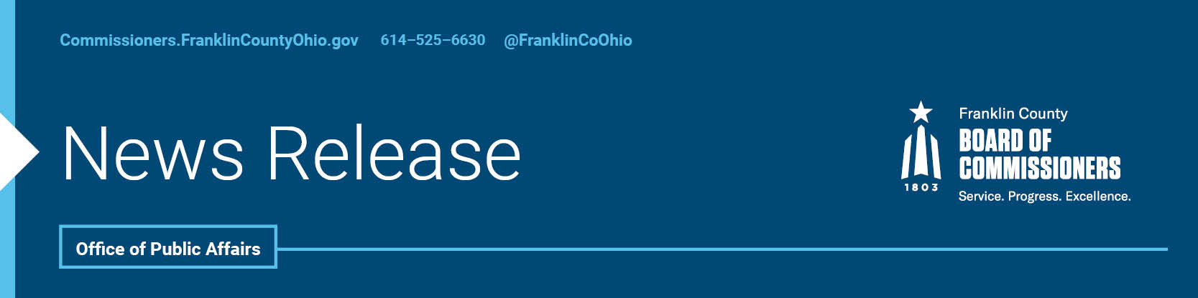

**FOR IMMEDIATE RELEASE**

Wednesday, April 30, 2025

Contact: Robin Ross, Commissioners, 614/525-2392

Isabella Minadeo, Commissioners, 614/525-3462

**COMMISSIONERS’ ANNUAL STATE OF THE COUNTY REPORT HIGHLIGHTS PROGRESS AND FUTURE PRIORITIES FOR A STRONGER COMMUNITY**

**Franklin County, Ohio** - This morning, the Franklin County Commissioners released their tenth annual State of the County report, offering a clear and comprehensive look at how county government is delivering results and expanding opportunity in every corner of the community. Organized around the Commissioners' [six core principles of good governance](https://commissioners.franklincountyohio.gov/core-principles), the report highlights measurable outcomes and the many ways the 15 county agencies, other elected officials, and community partners are working together to support residents. It reflects the heart of the Commissioners’ mission—*Service. Progress. Excellence.* — and their daily commitment to building a stronger, more equitable Franklin County for all.

The report underscores the County’s strong commitment to equity, access, and good governance. It highlights the creative and compassionate ways Franklin County has tackled complex challenges, from bringing mobile health and human services directly into neighborhoods, to supporting residents reentering the community after incarceration, to helping families and seniors through a wide network of community-based programs.

"Throughout the past year, we have diligently focused on connecting individuals with the essential tools necessary to build better lives. Whether it’s through housing, health care, recovery, or childcare, our efforts are aimed at addressing the diverse needs of our community,” stated Board President, Commissioner Erica C. Crawley. “Our mission extends beyond merely delivering services; it is about fostering hope, dignity, and opportunity so residents can thrive and not just survive. I take great pride in our unwavering commitment to meet people exactly where they are on their journey."

Franklin County’s Office of Justice Policy and Programs helped nearly 10,000 individuals navigate reentry services through its Rapid Resource Centers, and more residents than ever before accessed medication-assisted treatment through the County’s addiction response programming, a 60% increase over the previous year.

The County’s economic strategy continued to deliver strong returns. More than 8,300 new jobs were created in partnership with regional economic organizations. Minority- and women-owned businesses received more than $56 million in purchasing contracts, marking a 74% increase. The County’s affordable housing efforts have supported nearly 1,700 new units since 2020, surpassing its decade-long goal in under four years.

“We’re not just investing in programs, we’re investing in people,” said Commissioner Kevin L. Boyce. “We’re helping build the kind of economy where everyone has a fair shot, whether they’re starting a business, returning to the workforce, or raising a family. Equity is not a side effort for us; it’s built into everything we do because that’s what it takes to create a thriving community.”

Franklin County’s commitment to public health and human services remains central. The Office on Aging delivered more than 2.7 million meals to seniors and provided over 112,000 hours of respite care to caregivers. The Job and Family Services agency supported more than 400,000 residents, nearly one in three Franklin County residents, with access to food, housing, child care, and job assistance.

“At the end of the day, it’s about making government work better for the people who count on us,” said Commissioner John O’Grady. “Every new housing unit we support, every meal we deliver, every child we help access early learning, it all adds up to a stronger, more connected community. And I truly believe we have the best team and partners in Ohio working to make that happen.”

Looking ahead, the Commissioners are prioritizing long-term solutions in housing, mental health, economic mobility, and neighborhood revitalization. They remain committed to transparency, fiscal responsibility, and effective governance, backed by a $2 billion annual budget and one of the strongest credit ratings for local governments in the nation.

The full report is available at [Report.FranklinCountyOhio.gov](https://report.franklincountyohio.gov/).

--30--

For more information on the Franklin County Board of Commissioners, log on to: <https://commissioners.franklincountyohio.gov>

