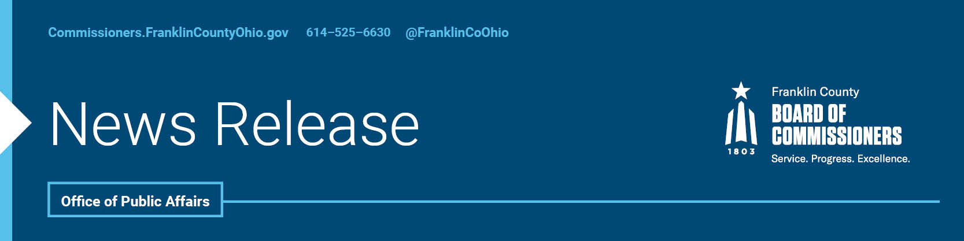

**FOR IMMEDIATE RELEASE**

**Tuesday, January 7, 2025**

Contact: Robin Ross, Commissioners, 614/525-2392

Isabella Minadeo, Commissioners, 614/525-3462

**FRANKLIN COUNTY COMMISSIONERS NAME ERICA C. CRAWLEY BOARD PRESIDENT FOR 2025**

At their first meeting of the year, the Franklin County Commissioners selected Commissioner Erica C. Crawley to serve as president of the Board for 2025. Commissioner Crawley, the first African American woman to be elected to the board and to hold the title of board president, has been a trailblazer in county leadership. She initially joined the Board in July 2021, appointed to complete a vacated term. She then served as board president in 2022 and was later elected to a four-year term.

Each year, the commissioners select one of their own to serve as the board president. The president oversees weekly General Session and Briefing meetings and serves as the primary spokesperson for the Board of Commissioners at community events, meetings, and media outreach. The Board of Commissioners is responsible for managing Franklin County's 15 agencies and setting the county's budget, which exceeds $2 billion.

Commissioner Crawley brings a wealth of experience and dedication to her position. A native of Youngstown, Ohio, she holds a degree in criminology, a master’s in public administration, and a Juris Doctorate from Capital University Law School. Her career has consistently been focused on service to others, beginning with her time in the U.S. Navy and continuing through roles with Cuyahoga County Job and Family Services, YMCA Head Start, CASA (Court Appointed Special Advocates for Children), and the Black Child Development Institute. In 2019, she was elected to the Ohio House of Representatives to represent the 26th District, serving southeastern Franklin County until her appointment to the Board of Commissioners.

Throughout her career, Commissioner Crawley has been a steadfast advocate for a range of vital issues, including expanding access to quality childcare and early education, advancing affordable housing solutions, enhancing addiction services and mental health care, improving maternal health outcomes, and supporting veterans in securing the benefits and services they deserve.

“I am deeply honored to lead the Board of Commissioners in 2025,” said Commissioner Crawley. “As we continue to grow and face new challenges, this is an exciting time for our county. It is essential that we approach this year thoughtfully and with a commitment to the future. I look forward to collaborating with my colleagues, county administration and our dedicated staff to build a strong, safe, and vibrant community, ensuring Franklin County remains the best place in America to not just survive but thrive, work, and raise a family.”

The Franklin County Board of Commissioners holds General Session meetings every Tuesday at 9:00 a.m., and Briefing meetings each Thursday at 9:00 a.m.  All meetings are open to the public and available online. For more information on meetings, including login details, visit [www.commissioners.franklincountyohio.gov/public-meetings](http://www.commissioners.franklincountyohio.gov/public-meetings). A full biography of Commission Crawley is available [here](https://commissioners.franklincountyohio.gov/COMM-website/media/Documents/Bios/Franklin-County-Commissioner-Erica-C-Crawley-Bio.pdf).

--30--

For more information on the Franklin County Board of Commissioners, log on to: <https://commissioners.franklincountyohio.gov/>

