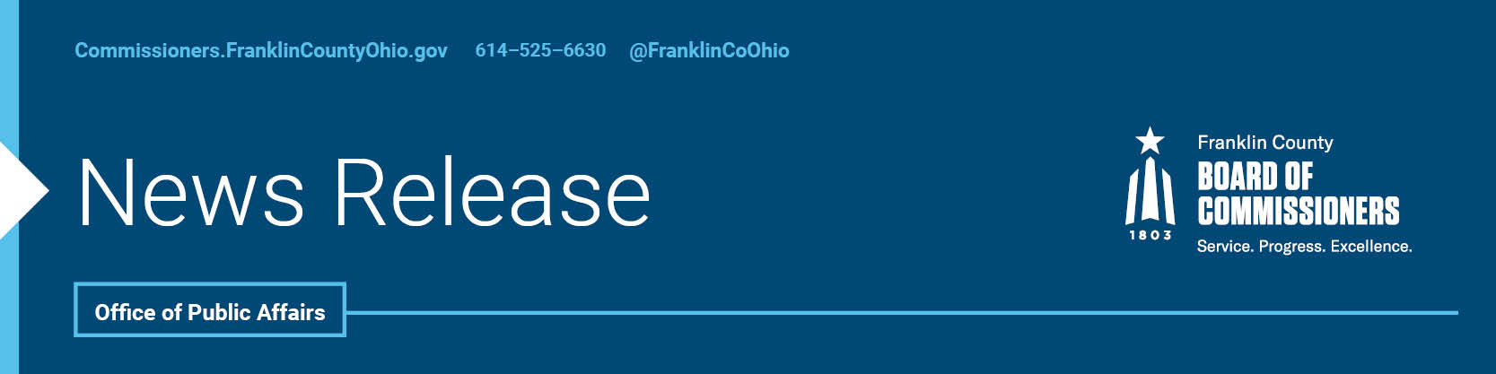

FOR IMMEDIATE RELEASE
Tuesday, June 6, 2021
Contact: Jodi Andes, Commissioners, 614/525-5273
Robin Ross, Commissioners, 614/525-2392

Board Statement on Columbus Zoo Allegations and Investigation

The Columbus Zoo and Aquarium Board of Directors has released a copy of their preliminary report. This report includes findings and recommendations from the independent investigation conducted by the law firm of Porter Wright. We are pleased that the zoo has also released these preliminary findings to the public and appreciate its efforts to be transparent with the investigation.
We are concerned about the extent of possible abuses raised by the Porter Wright investigation. We are in agreement with the report’s recommendations that further investigation is needed and that the investigation should be broadened to include all trading of products and services. We look forward to the additional recommendations that will be brought forth as this investigation moves forward.
We believe the findings support the critical need l for the zoo to adopt a structure for routine forensic audits and a separate accounting of taxpayer funds.
Franklin County voters extended their trust to zoo officials with passage of a levy that has generated more than $19 million from taxpayers in support of the zoo. We will continue to push for a separate accounting of these funds so that residents can have peace of mind that only full transparency can bring. We strongly urge any expenditures of these public funds to be approved by the forensic auditors while this matter is under investigation.
Zoo officials are committed to a review of the board’s governance, policy and protocols. The zoo’s governance structure is an unusual one, with multiple boards with different purviews and different appointing authorities. We firmly agree that a review of the governance, policy and protocols is needed. The Board of Commissioners is committed to assisting Zoo officials and the Board of Directors in any manner that will ensure that public funds are protected.
Additional Statement on behalf of Board President, Kevin L. Boyce:
These governing documents of the Columbus Zoo Board automatically make the president of the Franklin County Board of Commissioners an ex officio member of the Zoo Board, without any action from the Board of Commissioners.

Franklin County Board of Commissioners President Kevin L. Boyce remains committed to transparency in all matters related to the zoo. As an ex-officio member of the Zoo Board, President Boyce has called for changes in the governing structure and independent auditing.

--30--

For more information on the Franklin County Board of Commissioners, log on to: https://commissioners.franklincountyohio.gov/

