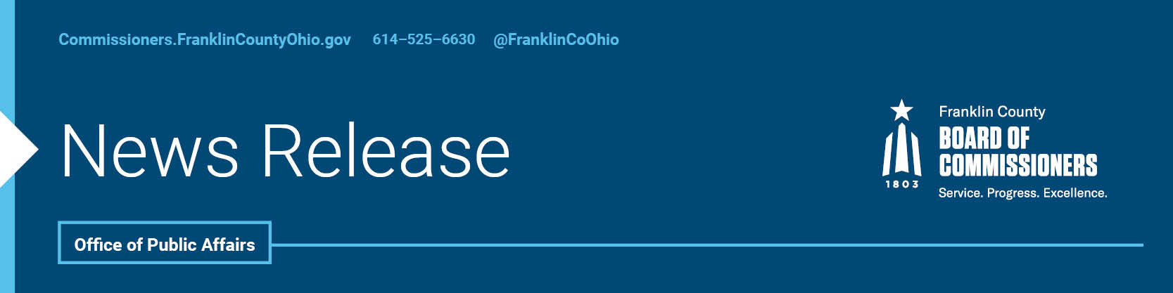

FOR IMMEDIATE RELEASE
Tuesday, June 1, 2021

Contact: Tyler Lowry, Commissioners, 614-525-6630
Jodi Andes, Commissioners, 614-525-5273

COMMISSIONERS’ STATEMENT ON PRIDE MONTH
The Franklin County Commissioners are proud of the annual Columbus Pride Festival and our community's collective work to establish Central Ohio as a smart, open, diverse, welcoming, and inclusive place to live. We look forward to celebrating in person again at the 2022 Pride Parade and Festival, and in the meantime encourage our residents to visit stonewallcolumbus.org to learn how to virtually celebrate Pride 2021—From a Moment to a Movement this year.

--30--

For more information on the Franklin County Board of Commissioners, log on to: https://commissioners.franklincountyohio.gov.

