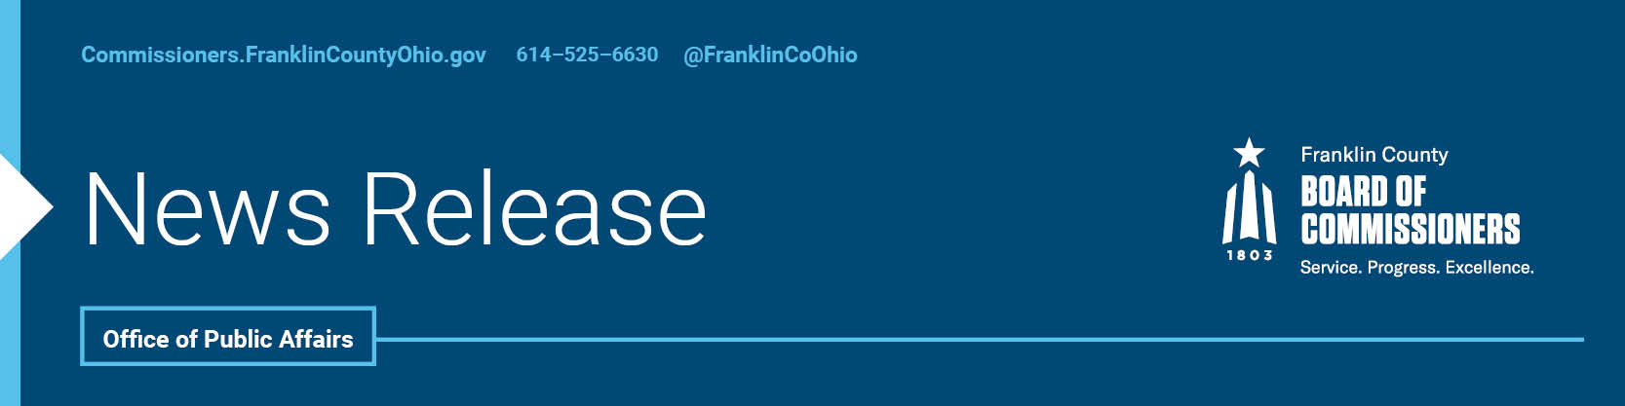

FOR IMMEDIATE RELEASE
Thursday, July 9, 2020
Contact: Jodi Andes, Commissioners, 614/402-5203
Robin Ross, Commissioners, 614/525-2392

County and City Provide Emergency Aid to Nonprofits in Need

Twenty million in grants are now available to Franklin County nonprofits, thanks to a joint effort by Franklin County and the City of Columbus officials to create a safety net for agencies that have helped so much, they are now in critical need themselves.

The partnership has been dubbed the Columbus and Franklin County Resilience Initiative and utilizes CARES Act funding.

“Nonprofits have been taxed with a tremendous amount of need during this pandemic. Many have exceeded their yearly budget already,” said Board of Commissioners President John O’Grady. “And we know their daily efforts are critical to our collective success.”

Agencies can access a single application to apply for funding from this joint fund which will be managed by the United Way of Central Ohio. The money can be used to cover revenue losses, new expenses and increased expenses incurred during COVID-19.
“Our nonprofit community has been doing extraordinary work in the midst of this global pandemic,” said Commissioner Marilyn Brown. “They have given everything to meet the critical needs of our community, while facing serious health and funding headwinds for their own staff and organizations. It is vital we take care of them as well.”
The $20 million fund is a continuation of on-going efforts by county and city officials to weather the pandemic. Franklin County is committing $5 million for this initiative, which supplements $19 million already committed in grants, loans, emergency assistance, and other aid provided during this crisis.
The City of Columbus is providing $15 million to this initiative.
“We know we are all in a collective fight against this virus. We will continue to innovate in ways that not only help residents survive, but with actions that also allow us to thrive in the future,” said Commissioner Kevin L. Boyce. “The partnership does just that by protecting our greatest social service assets and the needs of our residents.”
Any nonprofits interested in applying for the grants can take part in a webinar being put on by county and city officials. The webinar will be Friday, July 10th, at 10 a.m. and nonprofits must register in advance, and can do that by registering here.

Agencies must be a 501c3, in good standing and provide health and human services within Franklin County. Agencies with questions about the grant and application process can email humanserviceprograms@columbus.gov

--30--

For more information on the Franklin County Board of Commissioners, log on to: https://commissioners.franklincountyohio.gov/

