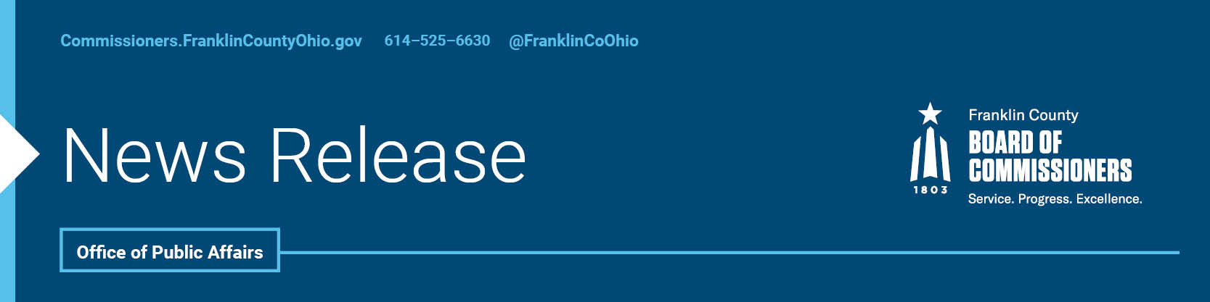

**FOR IMMEDIATE RELEASE**

**Saturday, March 22, 2025**

Contact: Robin Ross, Commissioners, 614/525-2392

Bart Logan, Dept. of Job & Family Services, 614/233-2030

**Franklin County Champions Free Tax Prep Service**

With the annual tax filing deadline quickly approaching, Franklin County is raising awareness about free tax preparation services available to thousands of residents and families. During their General Session Tuesday, the Franklin County Board of Commissioners highlighted the Tax Time program, which serves low- to moderate-income households.

Earlier this year, the Commissioners approved a contract between the Franklin County Department and Family Services and the United Way of Central Ohio, providing $75,000 in funding for Tax Time, a coalition of nonprofit, business, and government partners that aims to help residents maximize their returns, avoid preparation fees, and build wealth.

"As a former Tax Time volunteer, I have seen firsthand the tremendous impact this program has on our community," said Board President Commissioner Erica C. Crawley. "This initiative not only empowers our residents to maximize their tax returns, ensuring they receive every dollar they are entitled to, but it also safeguards them from costly and potentially predatory tax preparation services that can take advantage of those who may not be aware of their options."

Tax Time brings together the United Way’s Volunteer Income Tax Assistance (VITA) program and AARP’s Tax Counseling for the Elderly program under one comprehensive initiative. This tax season, residents can access free tax preparation services both in person and virtually at multiple locations across Franklin County.

“We encourage all residents to take full advantage of this service,” Commissioner John O’Grady said. “Every effort has been made to ensure accessibility, whether you prefer to meet with volunteers in person or simply find virtual support more convenient.”

Tax Time has prepared and processed more than 189,000 tax returns since its inception in 2007. Tax Time’s IRS-certified volunteers prioritize helping families claim their full refunds, including credits such as the Child Tax Credit and the Earned Income Tax Credit

“Ensuring that every eligible resident can access free, high-quality tax preparation is a vital step toward financial empowerment,” said Commissioner Kevin L. Boyce. “Tax Time helps families keep more of their hard-earned money, avoid costly fees, and claim the credits they deserve. This program is about strengthening financial futures and safeguarding economic stability for all our neighbors.”

Households, earning less than $67,000 last year are eligible for free preparation services. United Way Program and Grants Coordinator Brandi Cunningham reported that Tax Time has helped more than 2,000 in Franklin County this season.

Residents can learn more and sign up for appointments by calling 211 or visiting [liveunitedcentralohio.org/tax-time](https://liveunitedcentralohio.org/tax-time/).

--30--

For more information on the Franklin County Board of Commissioners, log on to <https://commissioners.franklincountyohio.gov/>

