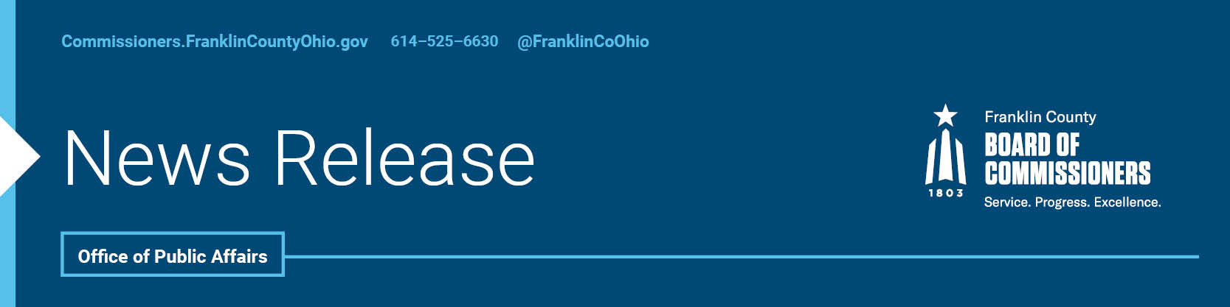

**FOR IMMEDIATE RELEASE**

**Tuesday, July 16th, 2024**

Contact: Isabella Minadeo, Commissioners, 614/525-3462

Robin Ross, Commissioners, 614/525-2392

**COMMISSIONERS RECOGNIZED NATIONALLY FOR EXCEPTIONAL RESIDENT CENTERED PROGRAMS**

Under the leadership of the Board of Commissioners Franklin County has received four prestigious awards from the National Association of Counties (NACo) for its innovative programming during their annual conference this past weekend. The first three highlight the effective work being done in local health and human services programing. Each year, NACo presents Achievement Awards to highlight exceptional programs across 18 categories, reflecting the diverse and comprehensive services provided by counties nationwide. The awards given to Job and Family Services, Office on Aging, and Justice Policy and Programs agencies underscore the hard work of each agency to strengthen services for Franklin County residents.

"We are honored to receive multiple NACo Achievement Awards, which recognize impactful public service and excellence in county government," said Board of Commissioners President Kevin L. Boyce. "This recognition reflects our Health and Human Services team's commitment to delivering outcomes for our residents and showcases our Franklin County initiatives designed to enhance the community."

The Department of Job and Family Services was honored in the Children and Youth category for its innovative [Franklin County RISE initiative](https://rise.franklincountyohio.gov/). This landmark investment by the Board of Commissioners aims to strengthen the foundation and close opportunity gaps in the local childcare system.

The [Office on Aging](https://officeonaging.org/default.aspx) received an Achievement Award in the Human Services category for its Bridge Team initiative. This program provides onsite case management and streamlines services for older residents, caregivers, and kinship caregivers, demonstrating a strong commitment to enhancing the well-being of the community.

The third was awarded to the Office of Justice Policy and Program in the Criminal Justice and Public Safety category for its Stop Addiction for Everyone Resource (SAFER) Station, which addresses addiction and supports public safety. [SAFER station](https://jpp.franklincountyohio.gov/initiatives) is a resource hub that offers accessibility for substance use treatment, located in one of the county’s top zip codes for fatal overdoses.

"These awards are a celebration of the collective effort and collaboration of our staff, partners, and community members,” said Commissioner John O’Grady. “It highlights our ongoing mission to enhance the quality of life for all residents through comprehensive health and human services. We are proud of this achievement and motivated to build on this success for a healthier, stronger community."

Since its founding in 1970, NACo’s Achievement Awards program has celebrated innovation in county government. By fostering a culture of creativity and proactive problem-solving, county leaders and employees develop and implement pioneering solutions that enhance the quality of life for residents. These innovations span various sectors, from public health and social services to community resources and support services, showcasing the dynamic and multifaceted nature of county operations. For more information about NACo’s Achievement Awards, click [here](https://www.naco.org/page/achievement-awards?_page=1).

“Winning these awards showcases our commitment to providing exceptional health and human services. It is a reflection of our team's unwavering passion and dedication to meeting the needs of our community.” said Commissioner Erica C. Crawley “We will continue to innovate and enhance our services to provide the highest quality of care and support, ensuring that our residents not only survive but thrive."

Additionally, the county’s IT leadership received an award for improving the digital experience for residents. Recognized in the category of a million or more residents, the county championed innovation by creating a new content management system for 44 agencies to modernize the county’s website so that services are easier for residents to find. Click [here](https://www.govtech.com/digital-counties-2024-1-million-or-more-population-category) for more information about the digital award.

The Franklin County programs, along with other innovative county programs from across the country, were celebrated at NACo’s Annual Conference and Exposition in Hillsborough County, Florida this week.

--30--

For more information on the Franklin County Board of Commissioners, log on to: <https://commissioners.franklincountyohio.gov/>

