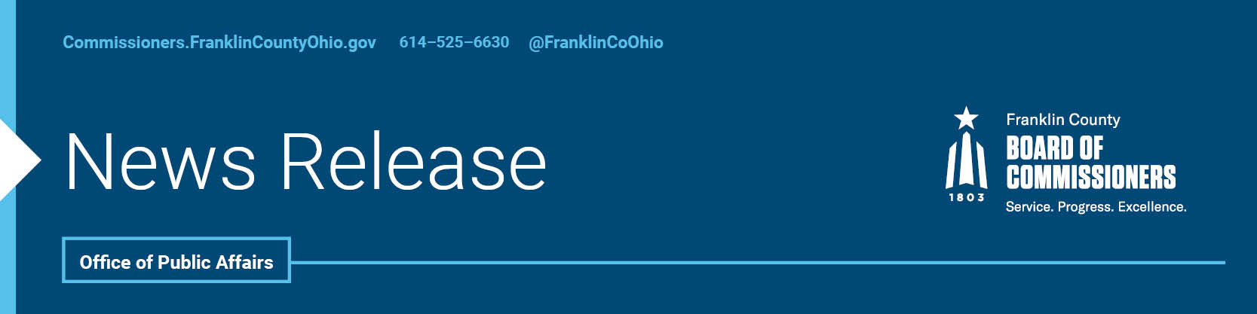

FOR IMMEDIATE RELEASE
Monday, September 21, 2020
Contact: Robin Ross, Commissioners, 614-525-2392
Tyler Lowry, Commissioners, 614-525-6630

Small Businesses Are Thrown a Lifeline During the Pandemic

The Franklin County Commissioners this afternoon highlighted a new Small Business Response and Recovery grant program to help local entrepreneurs weather the COVID-19 pandemic.
The grants total more than $1 million, and more are expected to be issued in the weeks and months ahead as the county continues to process applications. The loans were awarded to small businesses like salons and barber shops, childcare centers, building contractors, coffee shops, cleaning services and more.
“Our character is being tested in how we respond to this pandemic, and Franklin County is working to help residents through this difficult time. That is why we stress wearing masks to protect our neighbors and have created several different grant and loan programs for businesses. The more we help one another, the stronger we all become,” said John O’Grady, president of the Franklin County Board of Commissioners.
In addition to the Response and Recovery grants, the county provided $500,000 for revolving loans, which are still available today through the Economic Community Development Institute.
The county’s funding is also in addition to $6.75 million in Response and Recovery Grants provided by the City of Columbus. In all, more than 800 businesses have been given a total of 937 grants by the two governments.
These county and city efforts also inspired corporate giving, including JP Morgan Chase which provided $250,000 in grant matching funds.
The county and city utilized CARES Act dollars for these grants, which were provided by the federal government to help cities and counties weather the pandemic.
###
For more information on the Franklin County Board of Commissioners, log on to: commissioners.franklincountyohio.gov.

