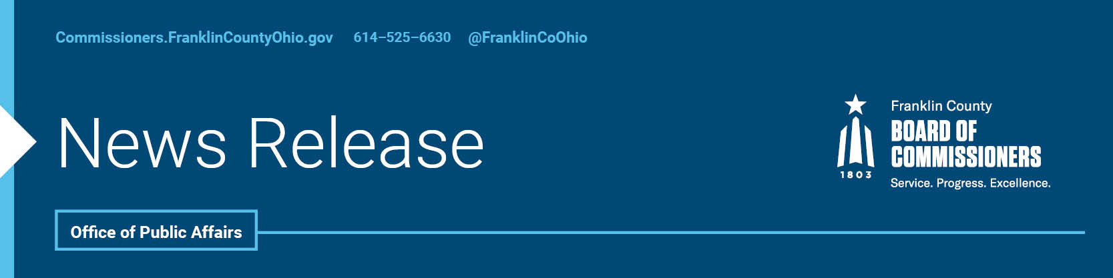

FOR IMMEDIATE RELEASE
Saturday, June 19th, 2021

Contact: Tyler Lowry, Commissioners, 614-525-6630
Jodi Andes, Commissioners, 614-525-5273

COMMISSIONERS’ STATEMENT ON JUNETEENTH
Juneteenth celebrates the abolition of slavery in America, and the recognition that African Americans are entitled to equal rights in this country they helped to build. Last year, the commissioners were proud to add it as a holiday for their employees (replacing Columbus Day) to recognize the struggle that so many have endured and are still enduring in order to realize the dream of a more perfect and equitable union.

--30--

For more information on the Franklin County Board of Commissioners, log on to: https://commissioners.franklincountyohio.gov.

