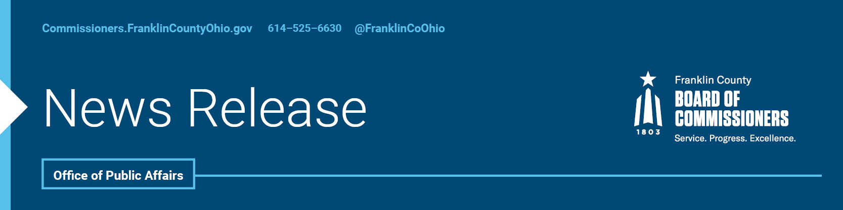

FOR IMMEDIATE RELEASE
Tuesday, April 5, 2021
Contact: Jodi Andes, Commissioners, 614/525-5273
Robin Ross, Commissioners, 614/525-2392
FRANKLIN COUNTY OFFICIALS RECEIVE DIVERSITY AWARDS
The Franklin County Board of Commissioners and the County’s Administrator - who launched and continue to lead a local effort which has public and private agencies combatting racial equity together - are being recognized for their diversity work.

Business First hosts annual diversity awards, which recognize leading inclusion efforts that bring “diversity in age, disability, gender, sexual orientation, race and religion” to the workplace. The awards are designed not only to be an honor; they also strive to provide exemplary role models for other businesses and organization who share these same goals.

The Franklin County Board of Commissioners were one of 10 organizations to be named as an Outstanding Diversity Organization. While Franklin County Administrator Kenneth N. Wilson was one of six people selected as an Outstanding Diversity Champion.

Board of Commissioners President Kevin L. Boyce, along with fellow commissioners Marilyn Brown and John O’Grady, added racial equity as one of the county’s fundamental principles in 2020, after years of leading racial equity efforts in Franklin County, including the Rise Together: A Blueprint for Reducing Poverty in Franklin County.

“These are awards we accept with great gratitude and honor,” Wilson said. “Mountains of evidence continue to show how our Black and other minority residents experience disparate outcomes with income, life-expectancy, infant mortality, healthcare and sadly so much more. We are committed to ensuring that not only are Franklin County’s greatest days ahead, there is and will be success available to all.”

The winners will be recognized virtually at a celebration on April 15.

Learn more at https://www.bizjournals.com/columbus/news/2021/03/08/diversity-in-business-awards-honorees.html

--30--

For more information on the Franklin County Board of Commissioners, log on to: https://commissioners.franklincountyohio.gov/

