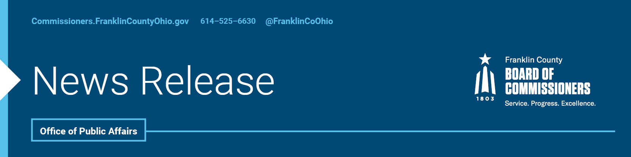

FOR IMMEDIATE RELEASE
Tuesday, May 26, 2020
Contact: Tyler Lowry, Commissioners, 614-525-6630
Jodi Andes, Commissioners, 614-525-5273

Franklin County’s Food Economy Now Offered Free, Specialized Help
These tools will help businesses to plan, launch or grow
Restaurants and other businesses that make up the local food economy have never had it easy with mass competition and low profit margins, but a new tool being launched today by the Franklin County Commissioners will give those businesses a competitive edge.
Businesses that make up Franklin County’s food economy are being offered a one-stop hub of resources and services. The hub is structured to help everyone from budding entrepreneurs with little more than an idea, all the way to existing restaurants and food suppliers who want to grow.
The Food Business Portal is available online through the Department of Economic Development and Planning thanks to funding from the Franklin County Commissioners.
“This is a tool we were working on pre-pandemic and we are pleased that we can launch now,” said John O’Grady, President of the Franklin County Board of Commissioners. “Though we initially thought this may help start-up businesses the most, we now believe it will also provide restaurants and suppliers a needed edge to begin rebuilding during this pandemic.”
The website breaks down assistance into three main categories: planning, launching and growing a business and allows businesses to select assistance in any one area or utilize them all.
“One thing that owners will love about this tool is its flexibility,” Commissioner Marilyn Brown said. “It helps them create a business plan, connect restaurants to local food chain suppliers, helps them navigate licenses and regulations, or institute new green practices.”
The online portal (https://fcfoodbusinessportal.org/) is available now.
"We strive to provide assistance for all our residents, and we know the restaurant and hospitality industries have been disproportionately affected during the pandemic,” Commissioner Kevin L. Boyce said. “However, we believe tools like this will help re-invigorate businesses and our economy.”
This online hub was developed with guidance from the Columbus & Franklin County Local Food Board and provides assistance that was called for in the Columbus & Franklin County Local Food Action Plan. More than a dozen agencies and businesses had a role in determining the content for the website and how it operates. To see a list of all those who assisted, click here.
“The Food Business Portal will define Franklin County as a national leader in supporting food entrepreneurship and growing local food businesses,” noted Tony Logan, Chair of the Columbus & Franklin County Local Food Board.
This resource includes a partnership with the Small Business Development Center (SBDC) and OSU Extension - Franklin County to provide no-cost business advising through the Portal for food-related business owners and entrepreneurs.
This announcement is the latest in a series of ways in which Franklin County is trying to help residents and businesses. The Franklin County Commissioners have approved nearly $15 million so far in workforce training, loans to businesses, assistance for families and other resources during this time of need.
Details of the help provided to residents during the pandemic can be found here, while information on assistance for businesses can be found here.
The press, business owners and residents can also learn more about this portal during an online discussion today. President O’Grady will host the chat at 1 p.m. via Facebook Live so that everyone can ask questions and learn more about it. Interested parties should go to https://www.facebook.com/FranklinCountyBoardofCommissioners/ and add questions in the Facebook stream they want answered.

-30-
For more information on the Franklin County Board of Commissioners, call the Office of Public Affairs at (614) 525-3322 or visit commissioners.franklincountyohio.gov.

